Assignment #4. Forms and Validation (HTML + Bootstrap)
Report
Item | Details
Name | [WRITE YOUR FULL NAME HERE]
Group | [WRITE YOUR GROUP HERE]
GitHub repository | [PASTE YOUR GITHUB REPOSITORY URL HERE, e.g. https://github.com/your-name/assignment4]
Files | task1.html + task1.css, task2.html + task2.css, task3.html
Tools | HTML5, Bootstrap 5.3 (CDN), my own CSS. No JavaScript and no novalidate attribute.

Task 1. Book a train ticket
I built the form with the Bootstrap grid (container, row, col-12 col-md-*) and Bootstrap form components. Then I changed the look with my own CSS file (task1.css): the colors from the task (#0F6B5F, #F2A93B, #16302B, #F4F7F5, #E6EFEC), the Montserrat font from Google Fonts, big rounded corners (I changed the Bootstrap variable --bs-border-radius), a soft shadow on the card and pill-shaped buttons. I did not use fixed widths or absolute positioning anywhere.

Screenshots: the picture from the task (left) and my result (right)
Laptop, 1280px
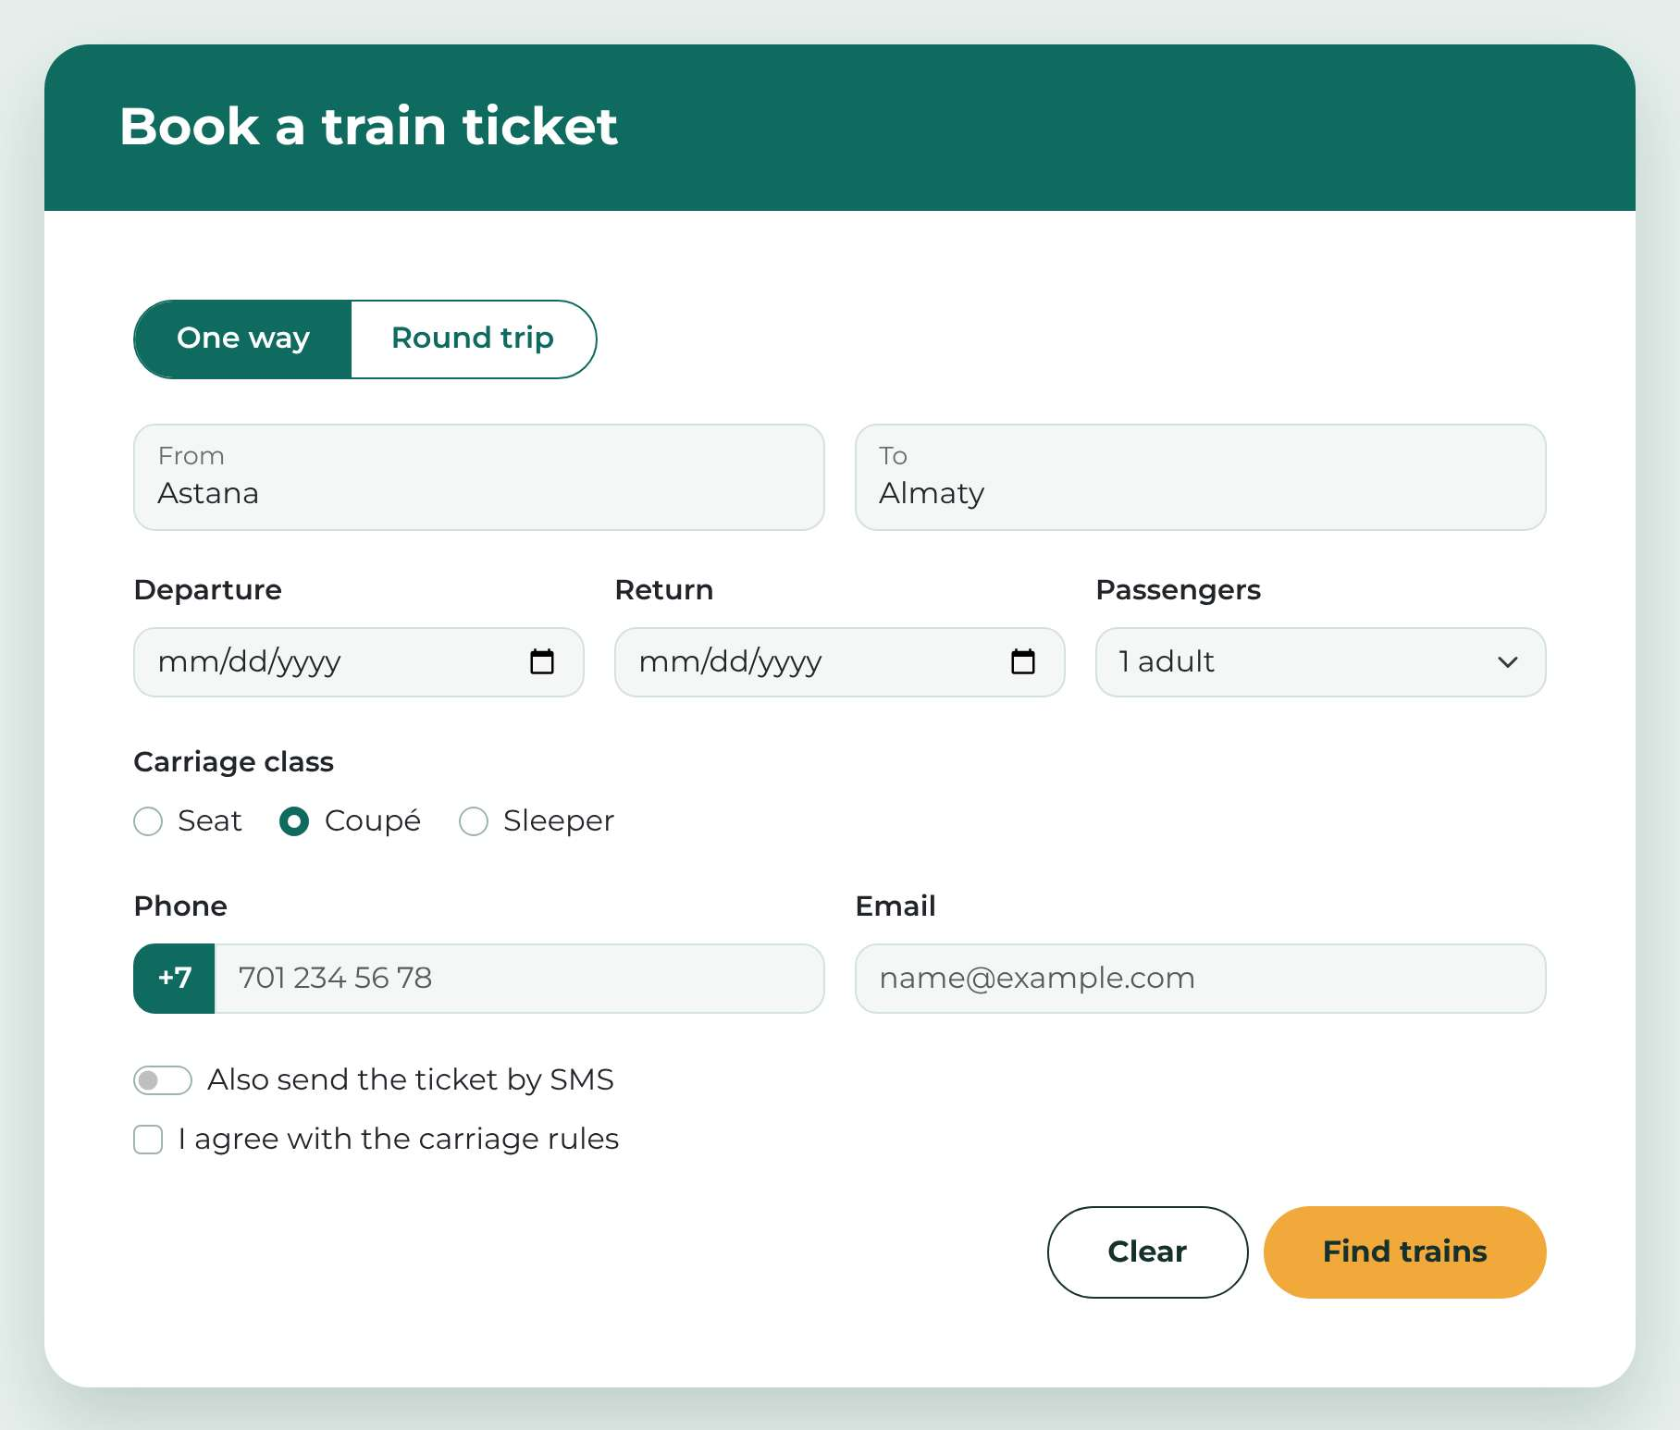  Picture from the task | 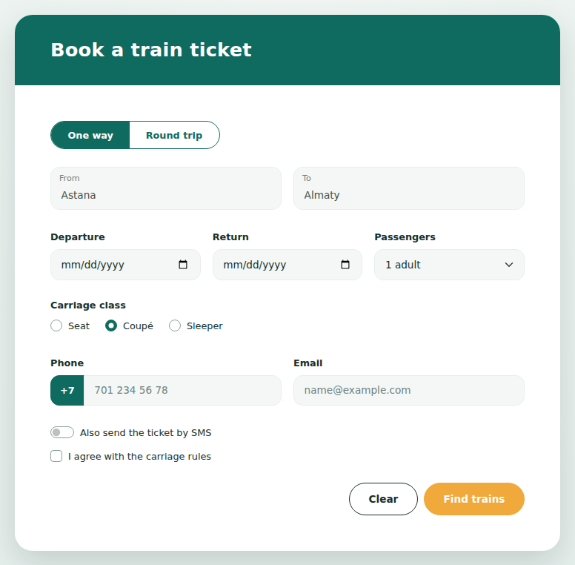  My page at 1280px

Phone, 375px
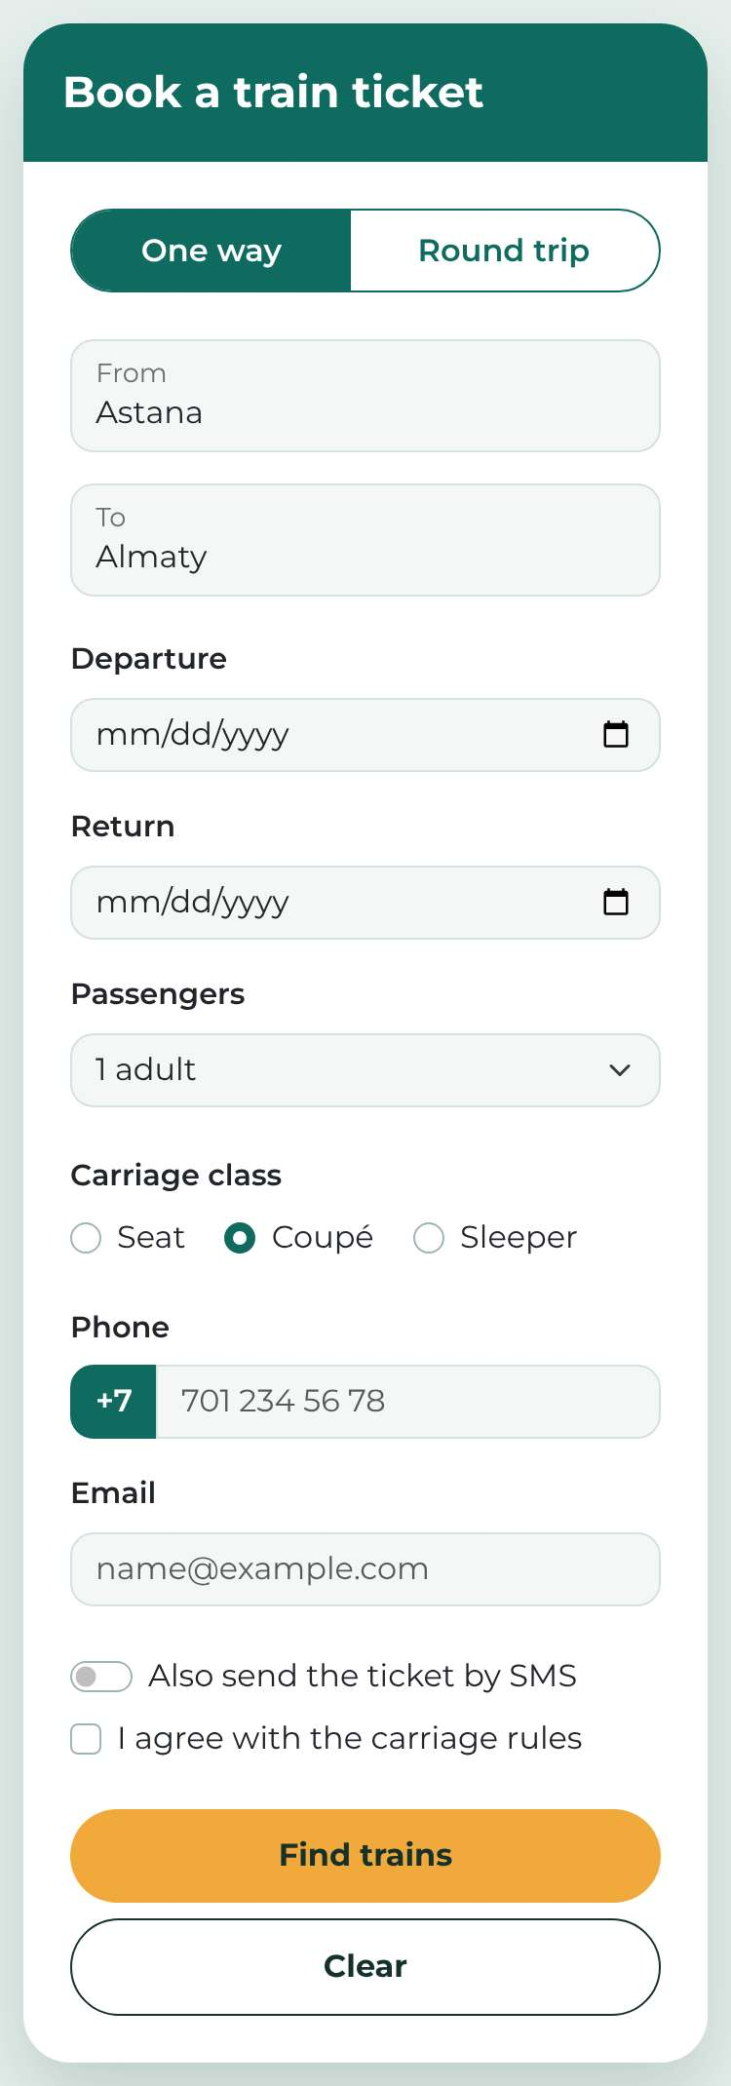  Picture from the task | 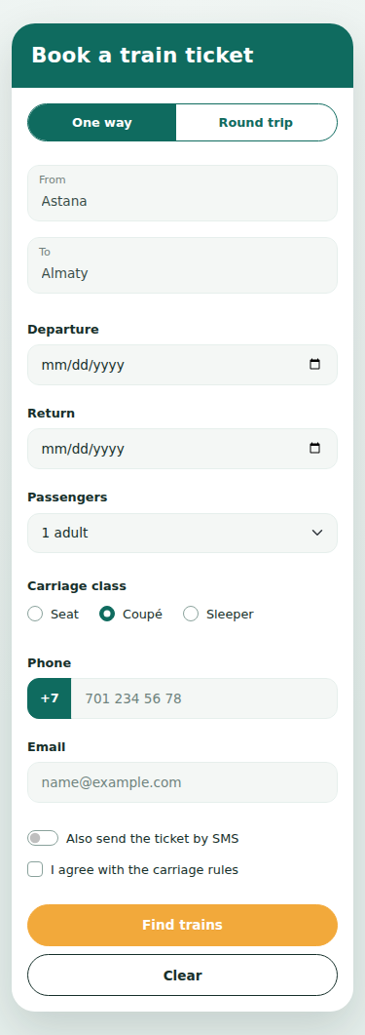  My page at 375px

Which Bootstrap component is used in each row
Row of the form | Bootstrap component | Main classes
One way / Round trip | Button group made from two radio inputs (checkbox/radio toggle buttons) | btn-group, btn-check (input type="radio"), btn; my class trip-toggle makes it a pill
From, To | Floating labels | form-floating, form-control; inside the grid col-12 col-md-6
Departure, Return | Date input with a normal label | form-label, form-control (type="date"), col-md-4
Passengers | Select | form-select, 6 options: 1 adult … 6 adults
Carriage class | Inline radios in a fieldset | form-check form-check-inline, form-check-input, form-check-label
Phone | Input group with a text add-on | input-group, input-group-text (+7), form-control (type="tel")
Email | Normal input | form-control (type="email")
Also send the ticket by SMS | Switch | form-check form-switch, role="switch"
I agree with the carriage rules | Checkbox | form-check, form-check-input
Clear / Find trains | Buttons | btn; my classes btn-clear and btn-find; Clear is type="reset", Find trains is type="submit"

Everything from “Please note”
- Two radio inputs. “One way” and “Round trip” have the same name="trip", so only one can be chosen. The input is hidden by btn-check and the label looks like a button.
- Find trains above Clear on a phone. In the HTML, Clear is first and Find trains is second. The button box has flex-column-reverse (phone) and flex-md-row (from 768px). In a reversed column the last item is on top, so on a phone the order is Find trains, then Clear. On a laptop the normal row order is back and both buttons are on the right. The HTML order is not changed.
- Required fields. From, To, Departure, Carriage class, Phone, Email and the agreement have the required attribute. Passengers is a select with values 1–6, so only 1–6 adults are possible.
- Clear. The Clear button is type="reset". The From and To texts are written as placeholders (not as values), so after Clear they are empty again and the dates, phone, email, switch and checkbox are empty too. The three starting choices from the picture (One way, 1 adult, Coupé) come back because they are the default state of the form.
- Labels and keyboard. Every input has a label with for/id. Radio groups are inside a fieldset with a legend. All elements are real inputs and buttons, so Tab, Shift+Tab, arrows (for radios), Space and Enter work. The focus ring is visible.

Task 2. Registration for AITU Hack 2026
All rules are written only with HTML attributes (type, required, min, max, step, minlength, maxlength). I did not use the pattern attribute, JavaScript or novalidate. To show errors, I used the CSS pseudo-classes :user-invalid and :user-valid. They work only after the user has changed a field or tried to send the form, so the page is clean when it opens. For example: input:user-invalid ~ .invalid-feedback { display: block; } (Bootstrap hides .invalid-feedback by default). For the radio group, the input group and the checkbox I used :has().

How every rule is written
Field | HTML attributes
Full name * | type="text" required minlength="2" maxlength="40"
University email * | type="email" required
Age * | type="number" required min="16" max="30" step="1"
Team size * | type="number" required min="1" max="4" step="1"
Track * | <select required> with the first option value="" (“Choose…”)
Arrival day * | type="date" required min="2026-11-20" max="2026-11-22"
Check-in time * | type="time" required min="09:00" max="18:00" step="1800" (step for time is in seconds: 1800 s = 30 min, counted from min)
Entry fee * | type="number" required min="0" max="5000" step="500"
Experience level * | three type="radio" with the same name="level", all with required
GitHub profile | type="url" without required (empty is allowed, but a link must start with https://)
Password * | type="password" required minlength="8" maxlength="20"
Motivation * | <textarea required minlength="50" maxlength="300">
Rules agreement * | type="checkbox" required

My results: values from the table
I tested every value from the task table in Chromium (typed values like a user; I also checked the validity state of each field). “Accepted” means the field is valid, “Rejected” means the browser shows the error and does not send the form. All results are the same as the task asks.
Field | Value | Must | Browser result | Check
Full name | Anna-Maria Lee | Accept | Accepted | OK
Full name | A | Reject | Rejected | OK
University email | a.fedenko@astanait.edu.kz | Accept | Accepted | OK
University email | a.fedenko | Reject | Rejected | OK
University email | a.fedenko@ | Reject | Rejected | OK
Age | 18 | Accept | Accepted | OK
Age | 15 | Reject | Rejected | OK
Age | 31 | Reject | Rejected | OK
Team size | 4 | Accept | Accepted | OK
Team size | 5 | Reject | Rejected | OK
Team size | 2.5 | Reject | Rejected | OK
Track | Web | Accept | Accepted | OK
Track | “Choose…” | Reject | Rejected | OK
Arrival day | 21.11.2026 | Accept | Accepted | OK
Arrival day | 25.11.2026 | Reject | Rejected | OK
Check-in time | 10:30 | Accept | Accepted | OK
Check-in time | 10:15 | Reject | Rejected | OK
Check-in time | 19:00 | Reject | Rejected | OK
Entry fee | 1500 | Accept | Accepted | OK
Entry fee | 1250 | Reject | Rejected | OK
Entry fee | 6000 | Reject | Rejected | OK
GitHub profile | (empty) | Accept | Accepted | OK
GitHub profile | https://github.com/yerassyl-dev | Accept | Accepted | OK
GitHub profile | github.com/yerassyl-dev | Reject | Rejected | OK
Password | Astana2026 | Accept | Accepted | OK
Password | short | Reject | Rejected | OK
Motivation | 120 characters | Accept | Accepted | OK
Motivation | 49 characters | Reject | Rejected | OK
Experience level | nothing chosen | Reject | Rejected | OK
Experience level | Beginner | Accept | Accepted | OK
Rules agreement | not ticked | Reject | Rejected | OK
Rules agreement | ticked | Accept | Accepted | OK

Screenshots
1) When the page opens there are no errors. 2) After I typed the bad values from the table and pressed Register, every field has a red border and an .invalid-feedback text. 3) With the good values, nothing is red.
Page just opened
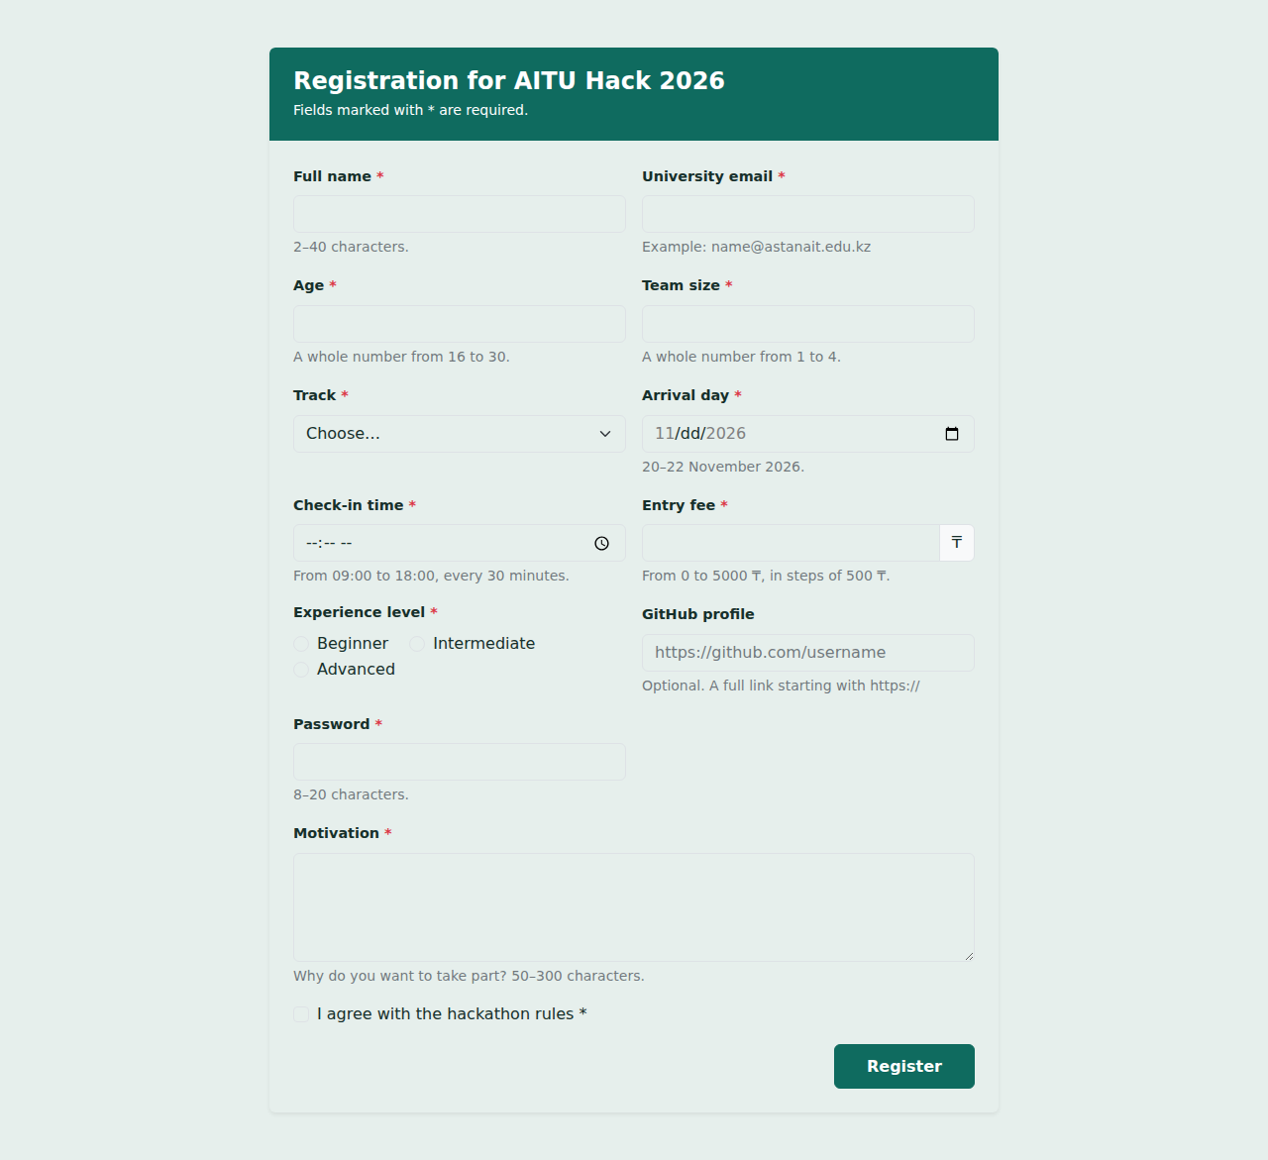
Bad values (errors are visible)
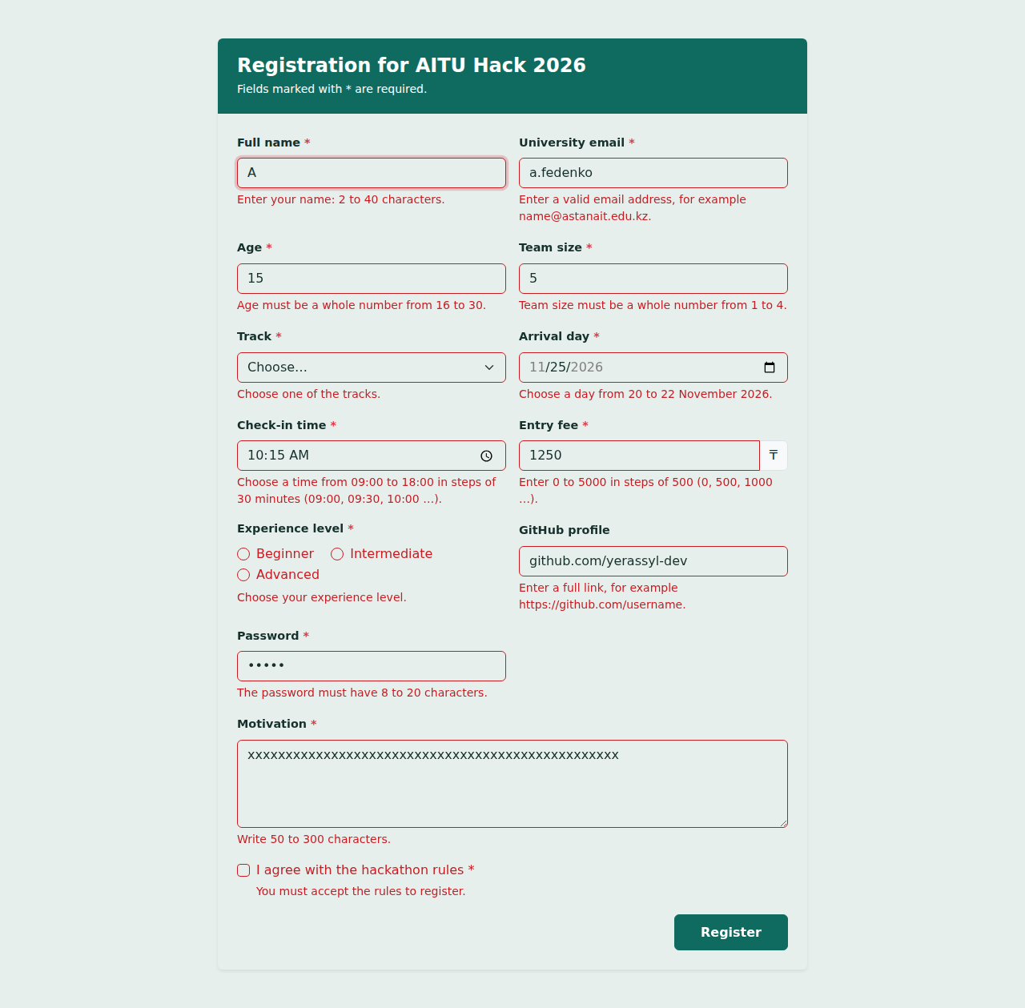
Good values
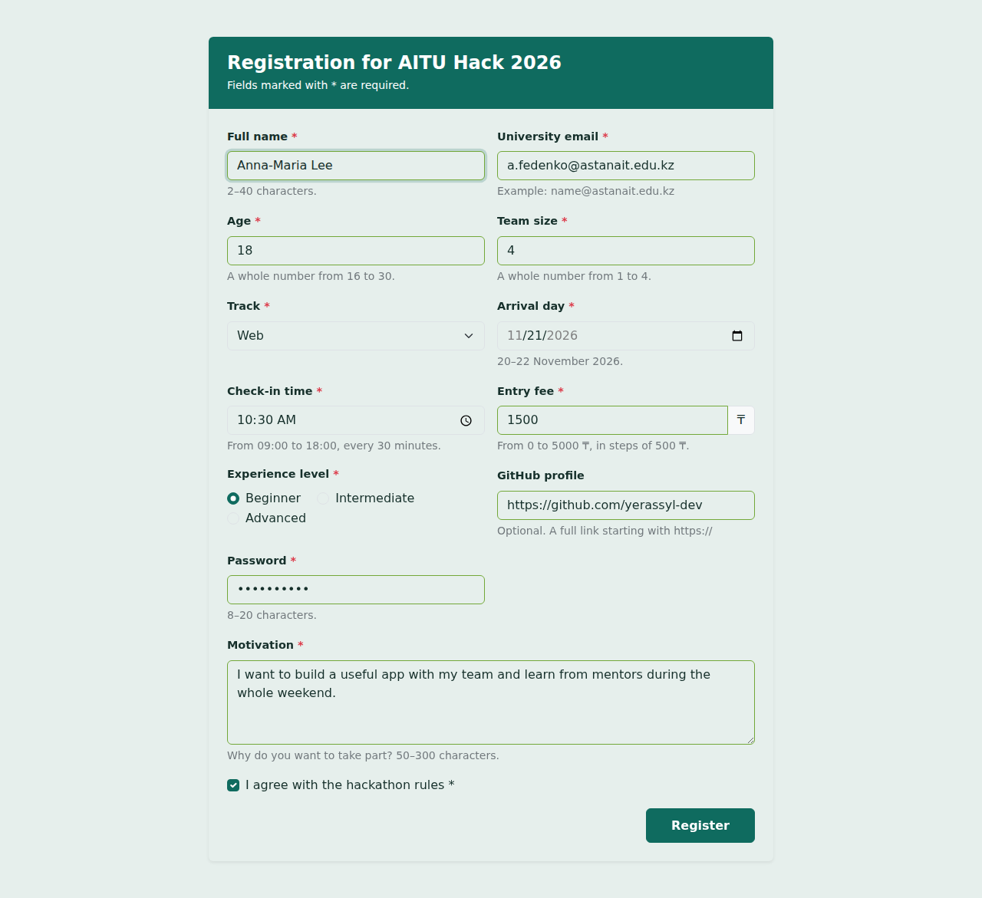

What I learned in this task
The input type already checks a lot: type="email" and type="url" refuse bad text without extra code. step is used not only for numbers: for time it is counted in seconds from min (so 10:15 is wrong but 10:30 is right), and for the fee it is counted from min too (0, 500, 1000 …). minlength is checked only when the user types the text, not when a script sets it, so a real person must change the field before the error appears.

Task 3. Fix a bad form
This is the original code of the café:
<h2>Reserve a table</h2>
<form>
<input type="text" placeholder="Your name">
<input type="text" placeholder="Email">
<label>Phone</label>
<input type="text" id="phone">
<label for="guests">Guests</label>
<input type="text" id="people">
<label for="date">Date</label>
<input type="text" id="date" placeholder="dd/mm/yyyy">
<p>Seating:</p>
<input type="radio" name="inside" id="date"> Inside
<input type="radio" name="terrace"> Terrace
<select>
<option>Lunch</option>
<option>Dinner</option>
</select>
<textarea placeholder="Comments"></textarea>
<input type="checkbox"> I agree to the terms
<div class="btn btn-primary">Reserve</div>
</form>

Table of problems
# | Line of code | Why it is a problem for the user | How I fixed it
1 | <input type="text" placeholder="Your name"> | There is no label, only a placeholder. When I start typing the hint disappears and I forget what the field is. The placeholder is light grey and hard to read, and a screen reader may announce only “edit text”. | Added <label for="name" class="form-label">Your name</label> and id="name".  Another possible fix: aria-label="Your name". It gives the field a name for a screen reader, but sighted users still see no text after typing and the tap area is small. I chose a visible label because it helps everybody.
2 | All fields: <input type="text" …>, <select>, <textarea>, checkbox, radios | There is no name attribute. The browser sends only fields with a name, so the café gets an empty reservation: part of the data is never sent. | Added a name to every field: name, email, phone, guests, date, seating, meal, comments, terms.
3 | <input type="text" placeholder="Email"> | The type is text and there is no label. The phone shows an ordinary keyboard without @, the browser does not check the address and it cannot autofill it. | type="email", autocomplete="email", a label and required.
4 | <label>Phone</label> | The label has no for attribute, so it is not connected to the input. A click on the word “Phone” does not focus the field and a screen reader does not read it. | <label for="phone"> connected with id="phone".
5 | <input type="text" id="phone"> | The type is text, so the phone shows the full letter keyboard and the browser does not help with a number. | type="tel" inputmode="tel" autocomplete="tel" and required.
6 | <label for="guests">Guests</label> and <input type="text" id="people"> | for="guests" but the input has id="people". The ids do not match, so the label is connected to nothing (click does not work, no name for a screen reader). | Same id on both sides: id="guests" and for="guests".
7 | <input type="text" id="people"> | The guests field is a text field: I can type “abc”, “-3” or “1000”. A phone shows a letter keyboard. | type="number" min="1" max="12" step="1" inputmode="numeric" required.
8 | id="date" is used twice: the text input and the first radio button | Two elements with the same id is a markup error. The label “Date” and any link or screen reader can point to the wrong element (the radio button). | Every id is unique: id="date" for the date and id="seating-inside" / id="seating-terrace" for the radios.
9 | <input type="text" id="date" placeholder="dd/mm/yyyy"> | The date is free text. People write “3/4/26”, “tomorrow” or the US format, and nobody checks it. There is no calendar on the phone. | type="date" with required. The browser gives a calendar and checks the date.
10 | <input type="radio" name="inside"> and <input type="radio" name="terrace"> | The two radios have different names, so they are not one group: both can be chosen at the same time, the arrow keys do not move between them and two different values are sent. | Both radios have name="seating" with value="inside" and value="terrace", and required.
11 | … name="inside" id="date"> Inside and … name="terrace"> Terrace | The words Inside and Terrace are plain text, not labels. Only the tiny circle can be clicked and a screen reader does not know what the radio is. | Each radio has <label class="form-check-label" for="…"> inside a Bootstrap .form-check.
12 | <div class="btn btn-primary">Reserve</div> | A div is not a button. The keyboard cannot reach it with Tab, Enter and Space do nothing, a screen reader does not say “button”, and it does not send the form. A keyboard user cannot reserve a table. | <button type="submit" class="btn btn-primary">Reserve</button>.  Another possible fix: <div role="button" tabindex="0"> with JavaScript for Enter/Space and form.submit(). I rejected it because it needs JavaScript (not allowed here) and repeats what a real button already does by itself.
13 | <p>Seating:</p> | The word “Seating” is just a paragraph, so it is not connected to the radios. A screen reader user does not hear what group the options belong to. | <fieldset> with <legend>Seating</legend> around the radio buttons.
14 | <select><option>Lunch</option><option>Dinner</option></select> | The select has no label and no name, so the user does not know what it chooses and the answer is not sent. The options have no value. | Added <label for="meal">Meal</label>, id="meal", name="meal" and value="lunch" / value="dinner".
15 | <textarea placeholder="Comments"></textarea> | Same problem as the name: only a placeholder, no label, no name. The text disappears when I type and the comment is not sent. | Label for="comments", id and name="comments", rows="3" and maxlength="500".
16 | <input type="checkbox"> I agree to the terms | The text is not a label, so only the small box is clickable. The checkbox is not required, so the form can be sent without agreeing, and it has no name. | id="terms" name="terms" required with <label for="terms">.
17 | <form> … </form> and no Bootstrap classes | No action/method, no form-control classes, no spacing: on a phone the fields are tiny and stand in one line, so it is hard to tap them. The snippet also has no viewport meta tag. | Added action="#" method="get", the Bootstrap grid, .mb-3, .form-control / .form-select / .form-check, and <meta name="viewport"> in the page head.

Rebuilt form: task3.html
I rebuilt the form with Bootstrap. It has the same fields in the same order (name, email, phone, guests, date, seating, meal, comments, terms, Reserve). Every field has a connected label, the radios are in one fieldset with one name, the right input types and required attributes are used, and the button is a real <button type="submit">. All ids are unique. Everything is reachable and usable with Tab, Shift+Tab, arrows, Space and Enter.
  Original form at 375px | 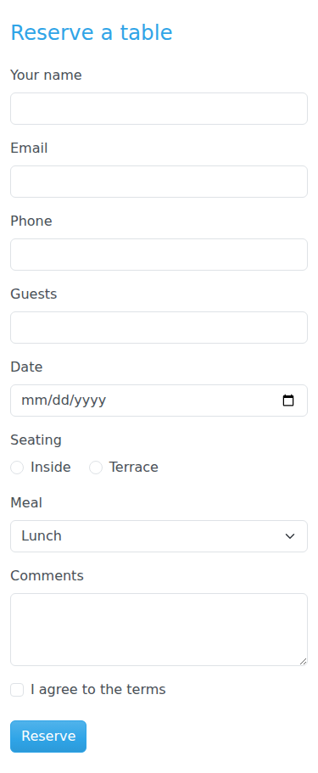  Fixed form at 375px

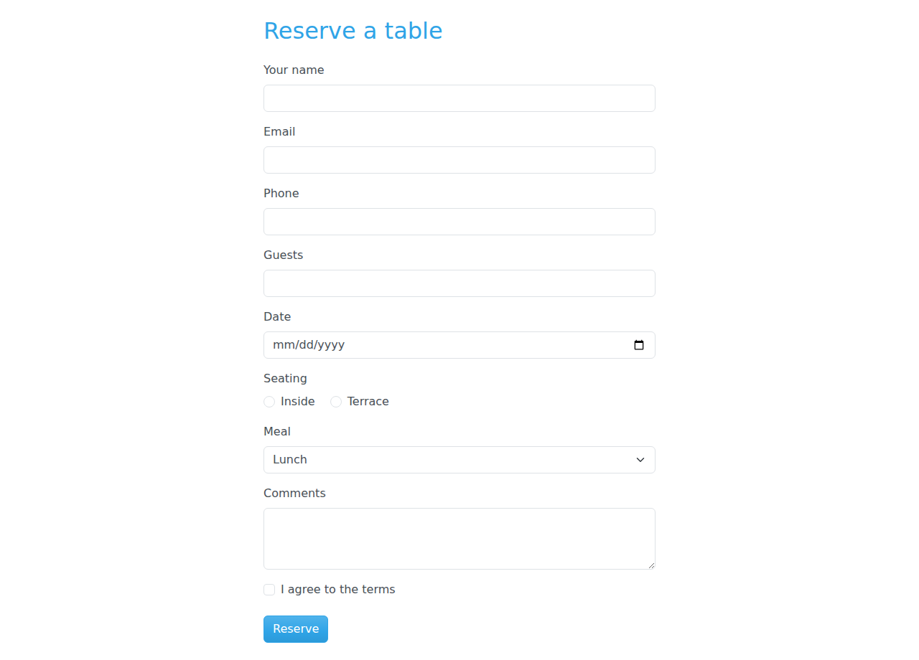
Fixed form at 1280px

W3C Markup Validator result for task3.html: the Nu Html Checker says “Document checking completed. No errors or warnings to show.”
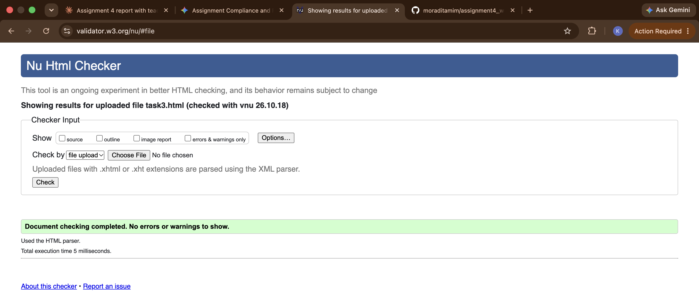

Conclusion
In this assignment I learned that a form is mostly about the right HTML elements. Bootstrap components (floating labels, input group, button group, switch) look nice but they are built on normal inputs and labels, so the keyboard and screen readers work. I learned that the browser can validate a lot without JavaScript if I choose the correct type and attributes (min, max, step, minlength, required), and that :user-invalid shows the error only after the user changes a field. I also learned how many small mistakes make a form hard to use: a missing name, a label not connected to the input, a div instead of a button, radios with different names. The hardest part for me was the step attribute for the time and the order of the buttons on a phone with flex-column-reverse.

GitHub repository
[PASTE YOUR GITHUB REPOSITORY URL HERE]

